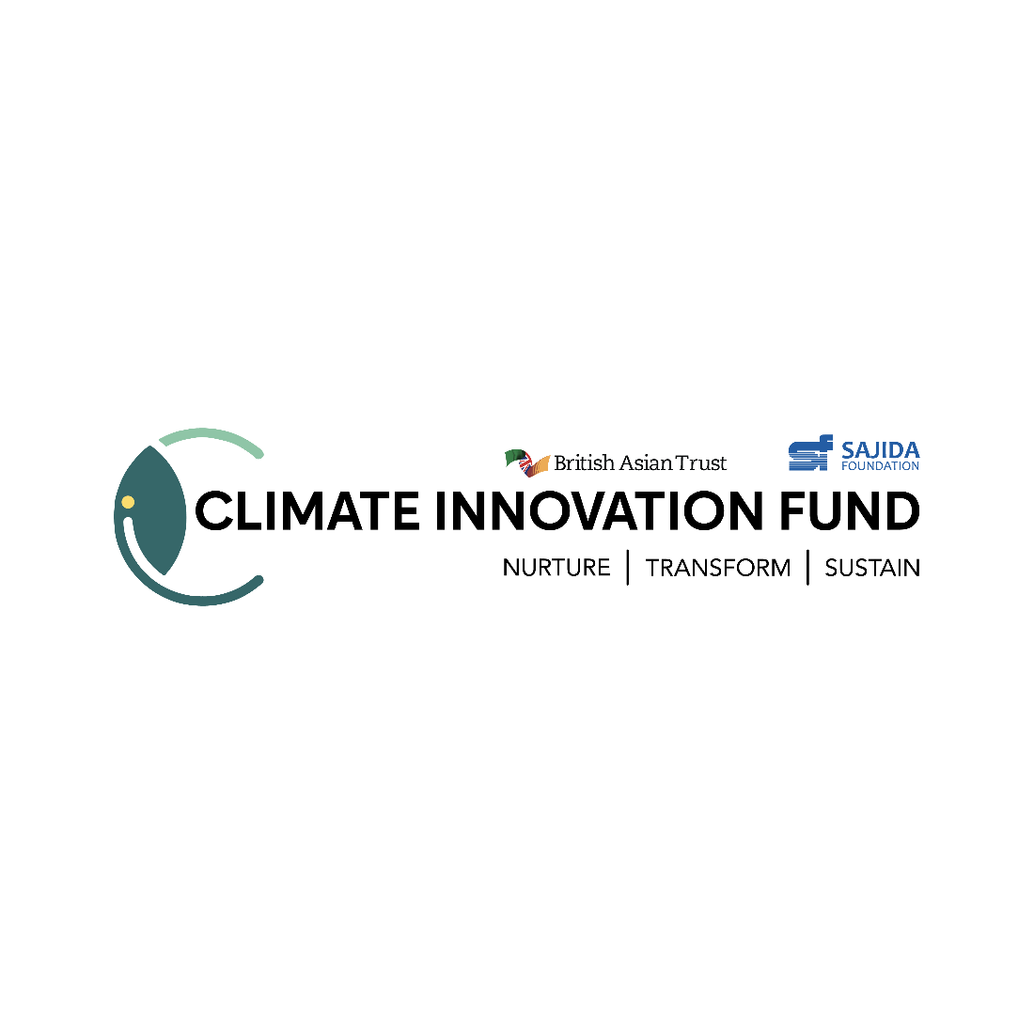
Application Form
Instructions:
- Please read the Application Guidelines before completing this document.
- Submissions must adhere to the prescribed format and the set page limits (Font: Calibri, Size: 12)
- Completed applications should be mailed to “cif@sajida.org” by 5:00 pm on 15 August 2023.
- Only shortlisted applicants will be contacted and invited to complete the full proposal. There is no need to share any additional documents at this stage of application.
- You are advised to keep a copy of your application for future reference.

- Overview (max. 1 page)
Name of Organisation/ Enterprise
Year of Establishment
Industry
Current Legal Status
(Sole Proprietorship/ Partnership/ Private Limited Company/ NGO, Other)
Thematic Area of Intervention
(Agriculture/ Food Security/ Water Security/ Livelihood)
Size
(Number of employees, Revenue earned/Grants received, Beneficiaries Served, Etc.)
Key Milestones Achieved
(Awards, recognition, fundings received, etc.)
Lead Contact for Proposal
(Name, Designation, Email and Contact number)

- Application Details (max. 3 pages)
Problem Identification – What is the problem(s) you are trying to solve?
Describe the climate vulnerabilities and impacts that your innovation is trying to address, the key characteristics and dynamics of the sector or market in which you are operating.

Approach to Solving the Problem(s)
Define your value proposition(s) – what are the activities your innovation is involved in, who are you serving, and what have you achieved till date. Please also indicate how your solution/ innovation fits in with the market gaps identified above, as well as the country’s national priorities and Sustainable Development Goals.
Activity/Approach | Details of activity/approach | Target Customers/Beneficiary groups | Traction till date / Achievements

Theory of Change
Please show your Theory of Change linking it to the approaches it is taking to solve the market problem and create an impact in mitigating climate crisis in Bangladesh. We are keen to understand the logic behind your approach, the longer-term outcomes, and the scalability of your approach.
Activities | Inputs Required | Output | Outcome | Impact

Competitive Landscape
How does your approach compare to that of its competitors? What is innovative about your approach? Provide a competitive analysis.
Current Challenges Faced
Describe the challenges that you are facing. How do you plan to utilize the support and funding provided by the Climate Innovation Fund to address them?
Key Business Risks and Mitigation Plan
Please indicate the relevant market risks, business risks, policy or economic risks to your innovation, including potential social and environmental risks that might prevent you from achieving your objectives. Please also propose measures that address these risks.

